**Automation of Student Education Verification and Services**

Dr. L. Jabasheela[1], H. Pooja[2], Priyadarshini Venkatesan[3], S. Sherline Calista[4]

Department of Computer Science and Engineering, Panimalar Engineering College, Chennai, India

Anna University, Chennai, India

Email: ssherlinecalista99@gmail.com

*Abstract*— *A Bonafide is a kind of proof that one is studying or working in a particular institution or firm for a specific duration. The certificate is demanded while applying for a passport, educational loans, universities, or when seeking a new job. In the same manner, a Letter of Recommendation is given to the admissions boards of the colleges a person is. applying to. Rendering a Bonafide certificate, Letter of Recommendation and verifying a student's background is an obligatory activity of every college. However, well established institutions at times may find it tedious to issue them when the procedure is extensive or when there is a substantial number of applicants. The proposed system is completely automated which decreases the time consumption and manual tasks performed during background verification and while issuing a Bonafide or an LOR. Using this web application, the student authentication process, request approval and providing letter can be done on a single platform from any place making it quickly accessible. As an added feature, a unique software is developed that automatically parses the mail contents sent by a background verifier and matches it with the student database to find if the information is genuine or not with an automated reply email.*

Keywords—Bonafide, Letter of Recommendation, Background Verification, Parsing, Automated

# **Introduction**

With current technology era where almost everything is substantially automated, the need of quick and efficient services is almost important in every aspects of our lives. especially when it comes to medical services. Providing a Bonafide certificate, Letter of Recommendation and verifying a student's background is a crucial task of every institution. However, well established organizations at times may find it tedious to issue them when the procedure is extensive or when there is a huge number of applicants*.*

A bonafide certificate has different uses for individuals belonging to all categories. An institution or organization issues a bonafide certificate upon the request of students, graduates, or employees. Generally, the certificate is attested and signed by the head of the institute or organization.

Individuals may require a bonafide certificate in the following circumstances:

* Students appealing for concessions or student permits granted by public transport companies such as city buses, local trains and metros.
* While applying for a passport.
* For visa forms during the allocation of abroad student visas or working overseas as an employee.
* For providing to institutions that may ask for granting loans to students at concessional charges.
* To apply for student scholarships that are offered.
* It can be used across all categories at the time of passport and visa application or extension.
* Students when shifting schools, applying for educational loans, and seeking admission to colleges and universities.

A letter of recommendation [describes a person's qualifications, ability and skills](https://www.thebalancecareers.com/letter-of-recommendation-template-2062920) as they relate to employment or education. These letters typically come from previous employers, professors, colleagues, clients, or teachers. They usually deliberate about the qualities and the potentialities that the person possesses which makes them a good fit for a given position, college, or a graduate program. Applicants typically request letters of recommendation from qualified individuals, who then send them directly to the employer, other hiring personnel, admissions committee, or department. Recommenders may offer them the freedom to review the letter before they send it, but they aren't obligated or expected to.

A Background verification process is a comprehensive inspection of a candidate’s educational background, degree obtained, credit scores and academic achievements. The process usually takes between 3-10 days for each candidate when the process is undertaken manually. In fact, every company runs a background check on one’s resume/CV, when the whole recruitment process is over and are qualified by the employees. There are many applicants who try to get hired by means of fake degrees and false employment records. A basic background verification check would uncover these frauds and cease them from hiring the wrong applicants.

Most of these processes are undertaken manually by humans which often makes it a very time-consuming task. The proposed system is a completely automated website application eliminates the need of man power and excessive time thereby making it seamless and impeccable. The students that require a Bonafide/Letter of Recommendation can directly raise a request for it right from their place of residence. After the approval of the higher authority it is made available to them in the portal itself. Similarly, a dedicated fully automated application is provided for Background Verification which the organizations can use to verify and send response to the verifier. When the application runs, the software automatically detects the unopened emails and parse/scrapes out the student’s data and checks it with the database to find if a student with the same data is present or not. If a match is found, a reply mail is sent stating that the data is verified. If not, a reply mail is sent stating that data is not verified.

# **WORKING OF MODULES**

## Request for Bonafide

In this module, the student will register and then login with their login credentials. The students can request for the certificates such as Bonafide certificate and Letter of Request (LOR) to any selected staff by selecting the reason for the need of those certificates. The HOD can approve or decline the certificates which are requested by the students. If the HOD approves the request, the student will be notified and a pop-up message will appear stating that the Bonafide request has been approved. Following which, the student’s name will be appended in the Bonafide template that is maintained already along with the seal and signature of the authority. The student can check the status of their Bonafide by logging into their account with the correct credentials. If the HOD approves the request for Bonafide, a download button will be provided in the student login page from which they can download their Bonafide.

## Request for Letter of Recommendation

In this module, the student will login with their login credentials. The students can request for the Letter of Request (LOR) certificate to any selected staff by selecting the reason for the need of those certificates. The reason for Bonafide must be selected from a predefined list. Upload a letter of your LOR and choose the faculty's name from the pre-defined list. Once the “Request for LOR” Button is clicked, the corresponding faculty is notified in their login. On approving their request, the student will be notified / a pop up message will appear in the login stating that the LOR request has been accepted. Following which, the contents of the letter will be appended in the LOR template maintained in the website along with the seal and signature of the authority. The student can check the status of their LOR by logging into their account with the correct credentials. A download button will be provided in the student login page by which they can download their LOR.

## Background Verification

This module is implemented in such a way that whenever background verification companies send email to institutions requesting for background verification for passed out students, the software automatically open the mail account and parse/scrape out the data and checks it with the database to find if the information provided is genuine or not. If a student with the same data is present, then a reply e mail is sent to the verifier stating that the details are verified. If not, reply mail states that the details are not verified.

.

# **SYSTEM ARCHITECTURE**

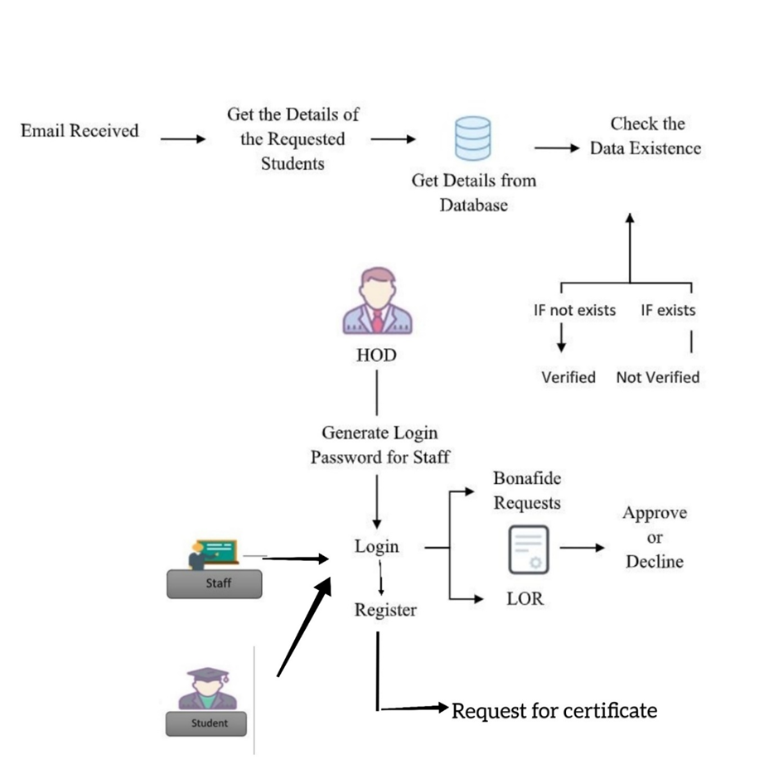

Fig 3.1

# **ApplICATION WORKFLOW**

## Request for Bonafide

Post Login, the request for bonafide is raised by the student on the website by clicking the appropriate button.

|

The reason for bonafide must be selected from a predefined list.

|

Click on the button “Request for bonafide”.

|

Once the “Request for Bonafide” button is clicked, the corresponding HOD is notified in their login.

|

The HOD can either approve or decline the request.

|

If the HOD approves the request, the student’s name will be appended in the bonafide template that is maintained already along with the seal and signature of the authority.

|

Following which, the student will be notified / a pop up message will appear stating that the bonafide request has been approved.

|

The student can check the status of their bonafide by logging into their account with the correct credentials.

|

If the HOD approves the request for Bonafide, a download button will be provided in the student login page from which they can download their bonafide.

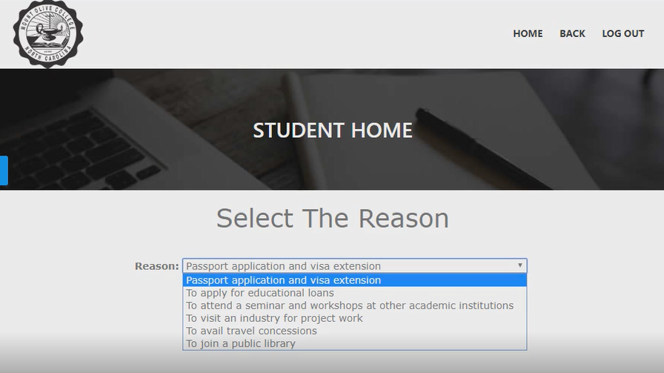

Fig 4.1

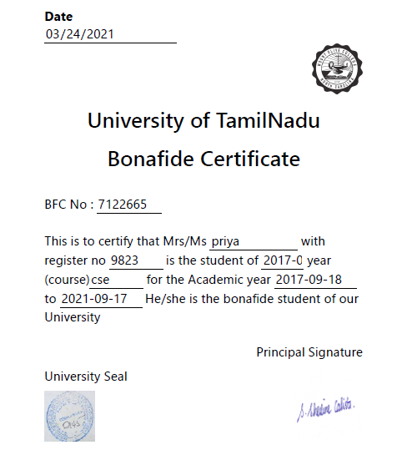

Fig 4.2

## Request for Letter of Recommendation

Post Login, the request for LOR is raised by the student on the website by clicking the appropriate button.

|

The reason for bonafide must be selected from a predefined list.

|

Upload a letter of your LOR and choose the faculty's name from the pre-defined list.

|

Once the “Request for LOR” Button is clicked, the corresponding faculty is notified in their login.

|

On approving their request, the contents of the letter will be appended in the LOR template maintained in the website along with the seal and signature of the authority.

|

Following which, the student will be notified / a pop up message will appear in the login stating that the LOR request has been accepted.

|

The student can check the status of their LOR by logging into their account with the correct credentials.

|

A download button will be provided in the student login page by which they can download their LOR.

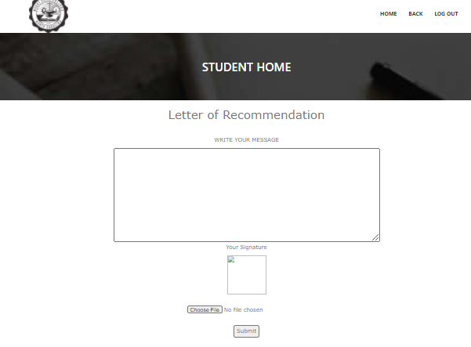

Fig 4.3

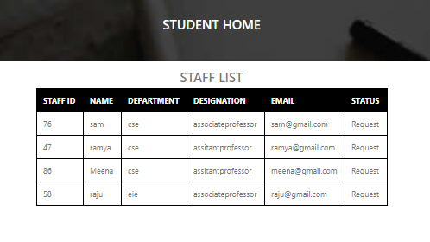

Fig 4.4

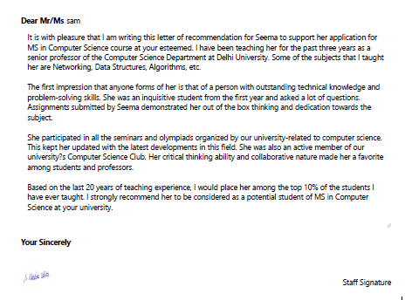

Fig 4.5

## Background Verification

Initially, verifier sends an email to the institution requesting Background Verification or passed out students

|

The software automatically detects the unopened emails and parse/scrape out the data.

|

The data is cross checked with the database to find if a student with the same data is present or not.

|

If the information is found to be genuine, then a reply mail is sent to the verifier stating that the “Data is Verified” else, the reply email states that the “Data is not verified”

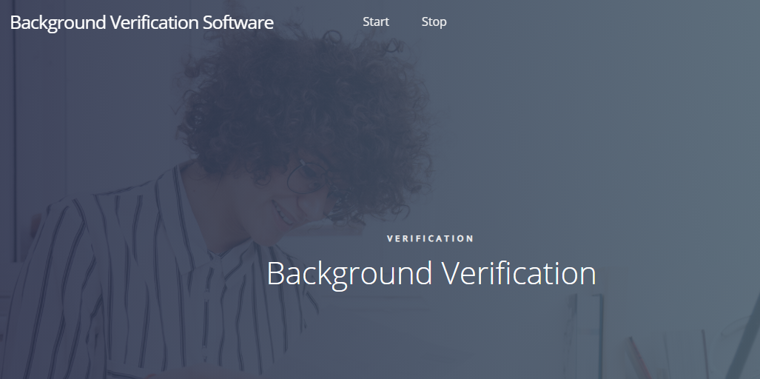

Fig 4.6

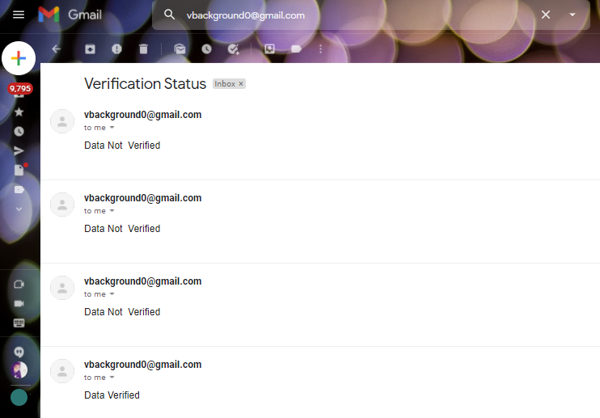

Fig 4.7

# **PERFORMANCE ANALYSIS**

Performance Analysis is majorly used to make sure that the loading time and the quality of the website is an asset rather than an obstacle to the users’ experience. It was done for both the websites to detect the quality and loading time issues. User experience is paramount and hence, it is considered as a very crucial step. The reports obtained are showcased.

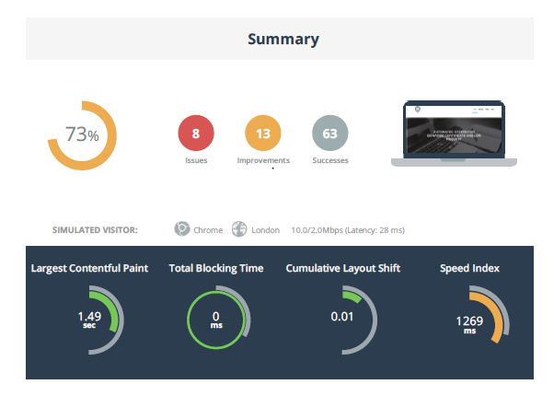

Fig 5.1

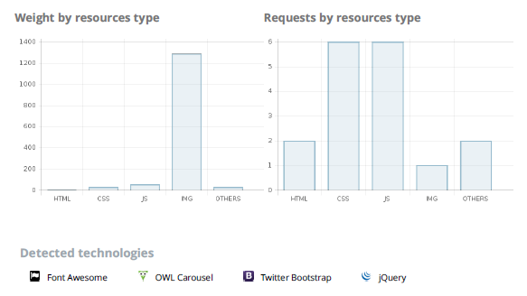

Fig 5.2

# **CONCLUSION**

The proposed system will drastically reduce the amount of time required by the students and staffs to apply, process and issue a bonafide and an LOR up to a very great extent as it is completely automated. Students can avail them right from their place of residence even during times of emergency. Along with this the organizations can also make use of the background verification software to verify a student’s background immediately. It is definitely a mandatory thing to switch over from utilizing man power and make use of automated systems in this fast-paced world.

##### **References**

[1] D. P. Mital and Goh Wee Leng, "Text segmentation for automatic document processing," Proceedings 1996 IEEE Conference on Emerging Technologies and Factory Automation. ETFA '96, Kauai, HI, USA, 1996, pp. 642-648 vol.2, doi: 10.1109/ETFA.1996.573971.

[2] K. Yang and J. Ho, "Parsing Publication Lists on the Web," 2010 IEEE/WIC/ACM International Conference on Web Intelligence and Intelligent Agent Technology, Toronto, ON, Canada, 2010, pp. 444-447, doi: 10.1109/WI-IAT.2010.206.

[3] Meng, "College Student Management System Design Using Computer Aided System," 2015 International Conference on Intelligent Transportation, Big Data and Smart City, Halong Bay, Vietnam, 2015, pp. 212-215, doi: 10.1109/ICITBS.2015.59.

[4] H. Baban and S. Mokhtar, "Online Document Management System for Academic Institutes," 2010 3rd International Conference on Information Management, Innovation Management and Industrial Engineering, Kunming, China, 2010, pp. 315-319, doi: 10.1109/ICIII.2010.555.

[5] V. Singrodia, A. Mitra and S. Paul, "A Review on Web Scrapping and its Applications," 2019 International Conference on Computer Communication and Informatics (ICCCI), Coimbatore, India, 2019, pp. 1-6, doi: 10.1109/ICCCI.2019.8821809.

[6] R. Diouf, E. N. Sarr, O. Sall, B. Birregah, M. Bousso and S. N. Mbaye, "Web Scraping: State-of-the-Art and Areas of Application," 2019 IEEE International Conference on Big Data (Big Data), Los Angeles, CA, USA, 2019, pp. 6040-6042, doi: 10.1109/BigData47090.2019.9005594.

[7] A. Rani, K. Mehla and A. Jangra, "Parsers and parsing approaches: Classification and state of the art," 2015 International Conference on Futuristic Trends on Computational Analysis and Knowledge Management (ABLAZE), Greater Noida, India, 2015, pp. 34-38, doi: 10.1109/ABLAZE.2015.7154963.

[8] F. Yue, "A study of student information management software," 2016 IEEE International Conference of Online Analysis and Computing Science (ICOACS), Chongqing, China, 2016, pp. 393-396, doi: 10.1109/ICOACS.2016.7563123.

[9] Fangxing Lv, Xiaoyao Xie, Cuicui Zhang and Xingjing Cheng, "Research and development of E-mail program based on Java," 2009 3rd International Conference on Anti-counterfeiting, Security, and Identification in Communication, Hong Kong, China, 2009, pp. 80-84, doi: 10.1109/ICASID.2009.5276955.

[10] Chuchang Liu, M. A. Ozols, T. Cant and M. Henderson, "Towards certificate verification in a certificate management system," *Proceedings 23rd Australasian Computer Science Conference. ACSC 2000 (Cat. No.PR00518)*, 2000, pp. 150-157, doi: 10.1109/ACSC.2000.824396.

[11] Rosmasari *et al*., "Usability Study of Student Academic Portal from a User’s Perspective," *2018 2nd East Indonesia Conference on Computer and Information Technology (EIConCIT)*, 2018, pp. 108-113, doi: 10.1109/EIConCIT.2018.8878618.

[12] F. Yue, "A study of student information management software," *2016 IEEE International Conference of Online Analysis and Computing Science (ICOACS)*, 2016, pp. 393-396, doi: 10.1109/ICOACS.2016.7563123.

[13] N. Pham and B. M. Wilamowski, "IEEE article data extraction from internet.," *2009 International Conference on Intelligent Engineering Systems*, 2009, pp. 251-256, doi: 10.1109/INES.2009.4924771.

[14] P. T. Kannan and S. K. Bansal, "Unimate: A student information system," *2013 International Conference on Advances in Computing, Communications and Informatics (ICACCI)*, 2013, pp. 1251-1256, doi: 10.1109/ICACCI.2013.6637357.

[15] D. K. Farkas, "A university Website design project: the design process, the prototype and some design issues," *Proceedings of IPCC 97. Communication*, 1997, pp. 311-319, doi: 10.1109/IPCC.1997.637059.